Test name: verifyLockedOutUserTest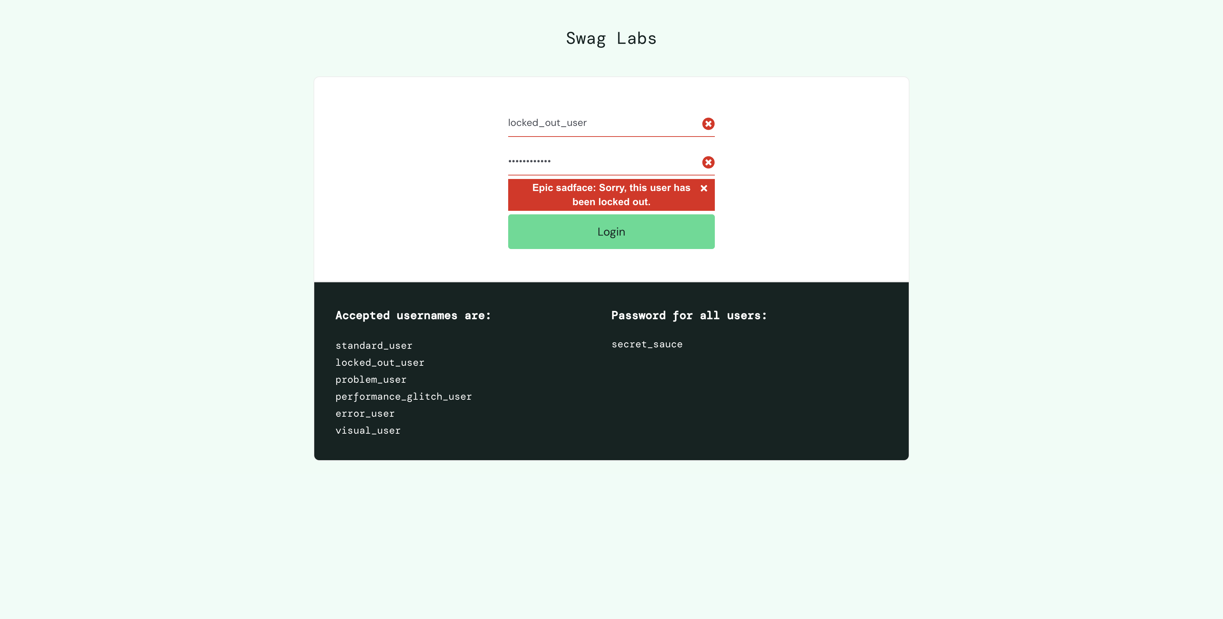

Test name: verifyProblemUserTest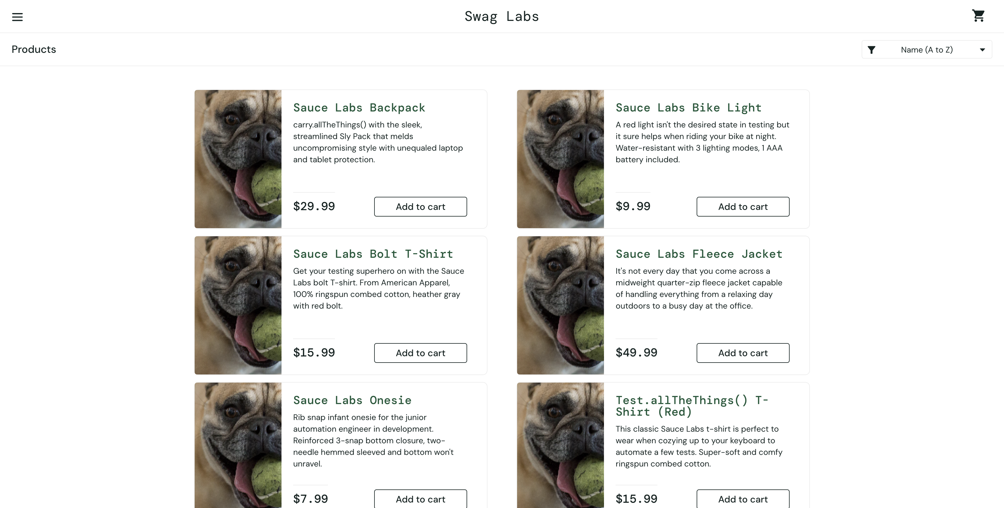

Test name: verifyPerformanceGlitchUserTest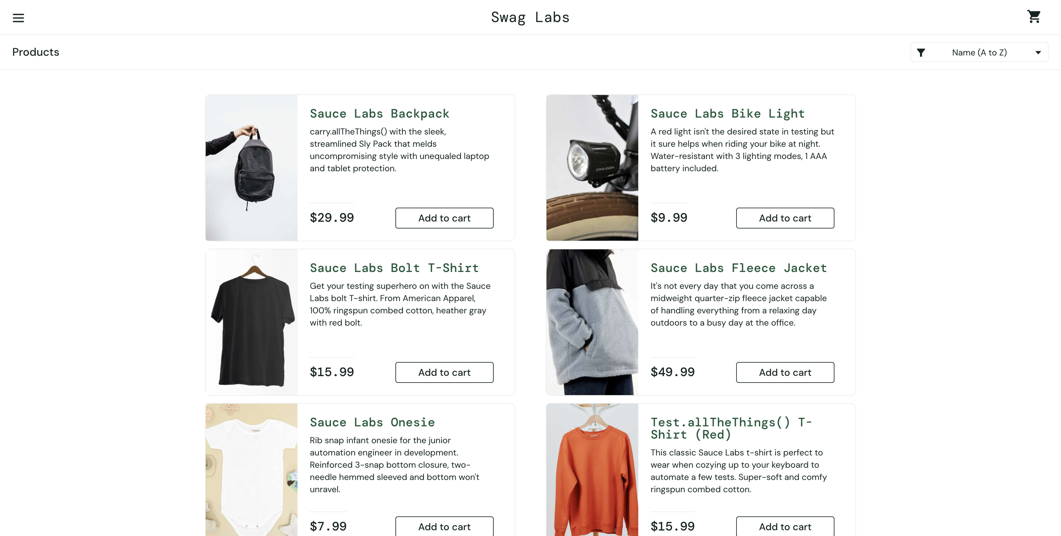

Test name: verifyErrorUserTest

Test name: verifyVisualUserTest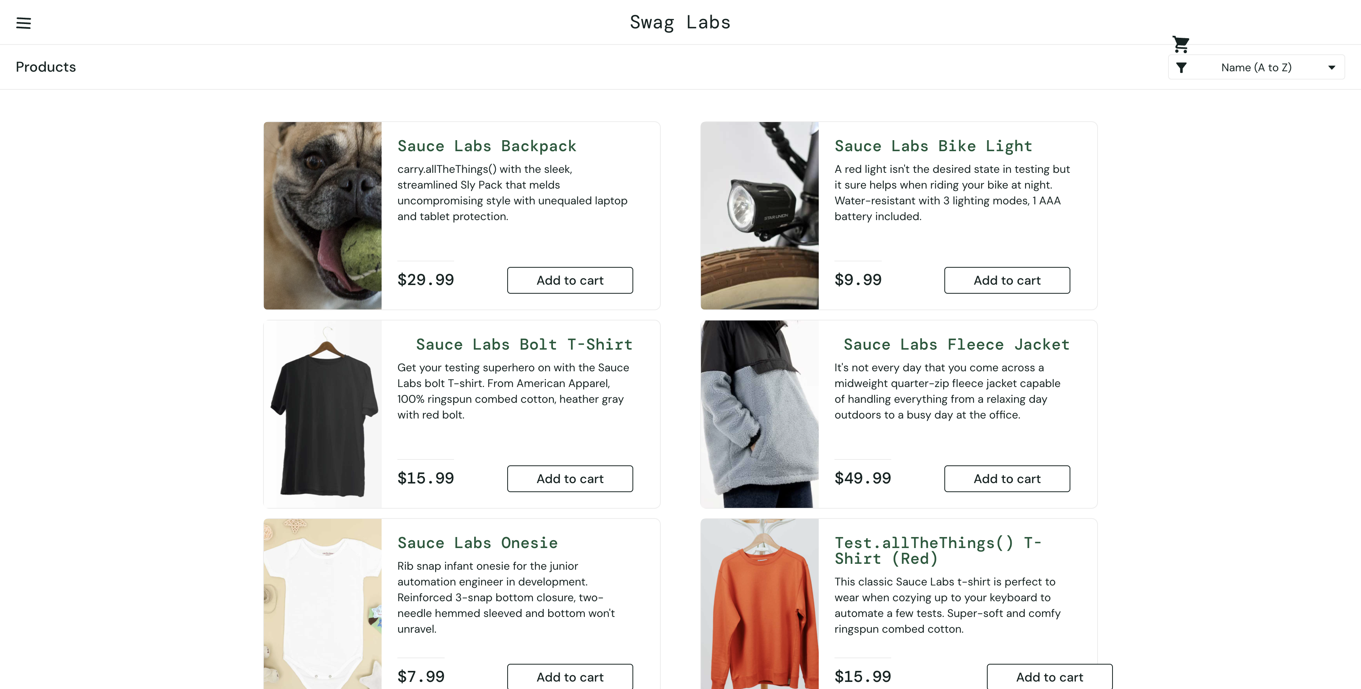

Test name: verifyLoginWithInvalidUserNameAndPasswordTest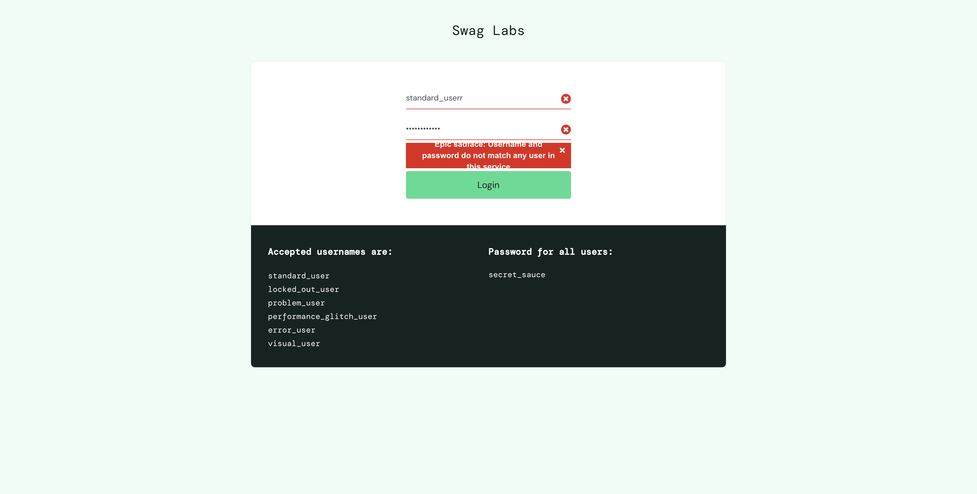

Test name: verifyLoginWithInvalidUserNameAndPasswordTest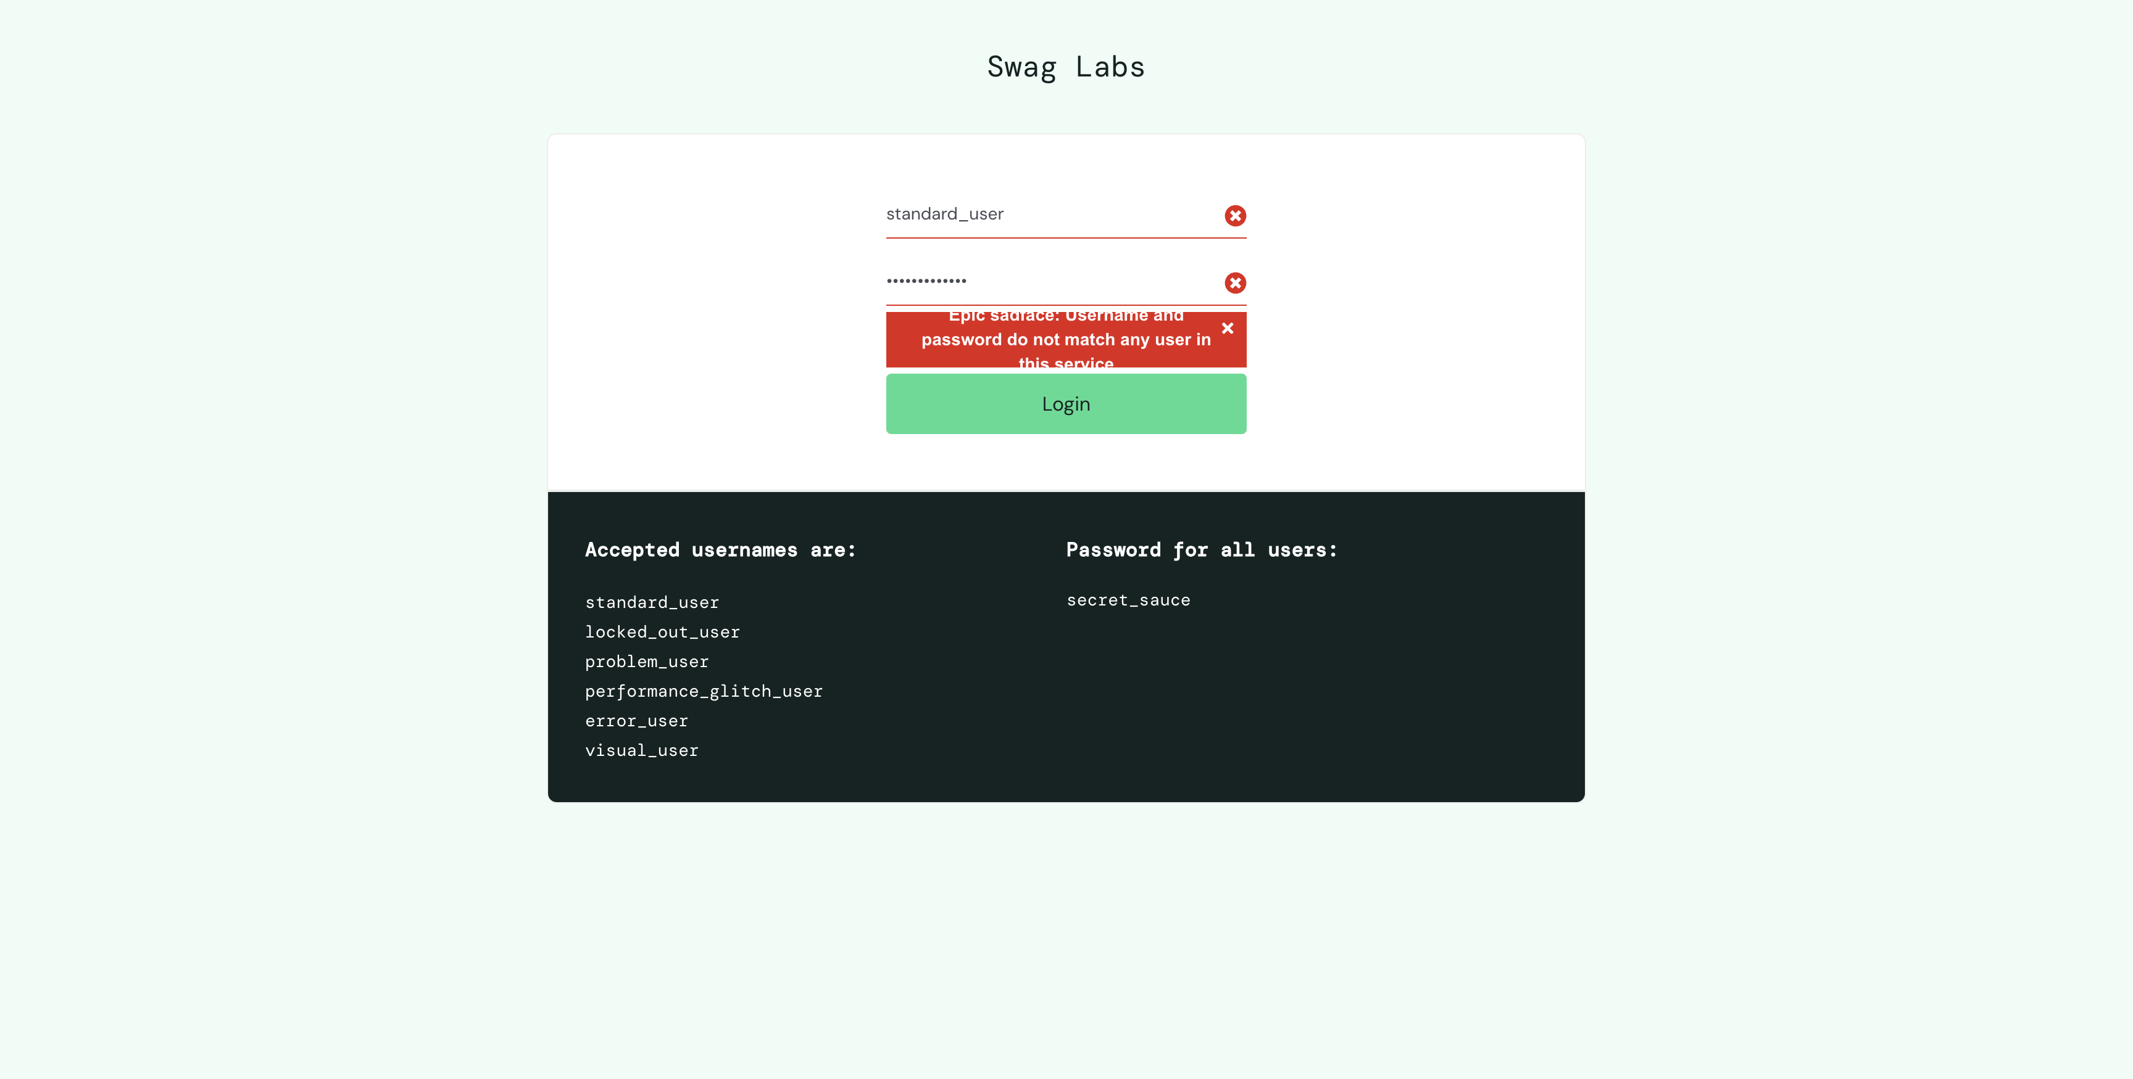

Test name: filterAtoZTest

Test name: verifyLoginWithValidUserNameAndPasswordTest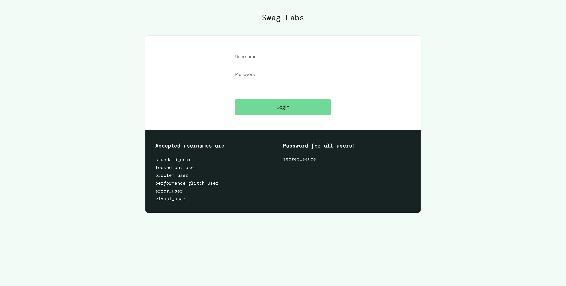

Test name: verifyLockedOutUserTest

Test name: verifyProblemUserTest

Test name: verifyPerformanceGlitchUserTest

Test name: verifyErrorUserTest

Test name: verifyVisualUserTest

Test name: verifyLoginWithInvalidUserNameAndPasswordTest

Test name: verifyLoginWithInvalidUserNameAndPasswordTest

Test name: filterAtoZTest

Test name: verifyLockedOutUserTest

Test name: verifyProblemUserTest

Test name: verifyPerformanceGlitchUserTest

Test name: verifyErrorUserTest

Test name: verifyVisualUserTest

Test name: verifyLoginWithInvalidUserNameAndPasswordTest

Test name: verifyLoginWithInvalidUserNameAndPasswordTest

Test name: filterAtoZTest

Test name: verifyLockedOutUserTest

Test name: verifyProblemUserTest

Test name: verifyPerformanceGlitchUserTest

Test name: verifyErrorUserTest

Test name: verifyVisualUserTest

Test name: verifyLoginWithInvalidUserNameAndPasswordTest

Test name: verifyLoginWithInvalidUserNameAndPasswordTest

Test name: filterAtoZTest

Test name: verifyLoginWithValidUserNameAndPasswordTest

Test name: verifyLockedOutUserTest

Test name: verifyProblemUserTest

Test name: verifyPerformanceGlitchUserTest

Test name: verifyErrorUserTest

Test name: verifyVisualUserTest

Test name: verifyLoginWithInvalidUserNameAndPasswordTest

Test name: verifyLoginWithInvalidUserNameAndPasswordTest

Test name: filterAtoZTest

Test name: filterZtoATest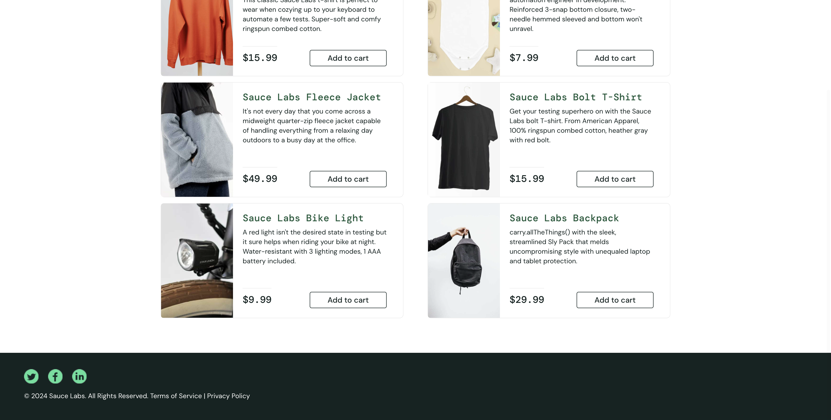

Test name: filterLowToHighTest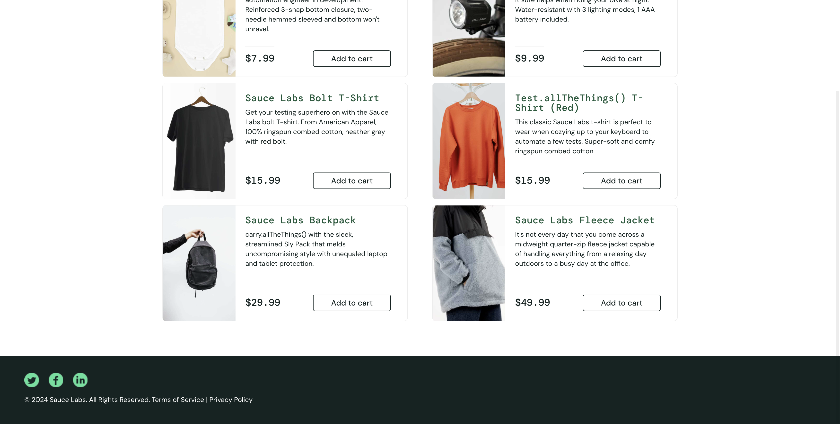

Test name: verifyLockedOutUserTest

Test name: verifyProblemUserTest

Test name: verifyPerformanceGlitchUserTest

Test name: verifyErrorUserTest

Test name: verifyVisualUserTest

Test name: verifyLoginWithInvalidUserNameAndPasswordTest

Test name: verifyLoginWithInvalidUserNameAndPasswordTest

Test name: verifyLockedOutUserTest

Test name: verifyProblemUserTest

Test name: verifyPerformanceGlitchUserTest

Test name: verifyErrorUserTest

Test name: verifyVisualUserTest

Test name: verifyLoginWithInvalidUserNameAndPasswordTest

Test name: verifyLoginWithInvalidUserNameAndPasswordTest

Test name: verifyProblemUserTest

Test name: filterAtoZTest

Test name: filterAtoZTest

Test name: verifyLoginWithValidUserNameAndPasswordTest

Test name: verifyLockedOutUserTest

Test name: verifyProblemUserTest

Test name: verifyPerformanceGlitchUserTest

Test name: verifyErrorUserTest

Test name: verifyVisualUserTest

Test name: verifyLoginWithInvalidUserNameAndPasswordTest

Test name: verifyLoginWithInvalidUserNameAndPasswordTest

Test name: filterAtoZTest

Test name: verifyLoginWithValidUserNameAndPasswordTest

Test name: verifyLockedOutUserTest

Test name: verifyProblemUserTest

Test name: verifyPerformanceGlitchUserTest

Test name: verifyErrorUserTest

Test name: verifyVisualUserTest

Test name: verifyLoginWithInvalidUserNameAndPasswordTest

Test name: verifyLoginWithInvalidUserNameAndPasswordTest

Test name: filterAtoZTest

Test name: filterZtoATest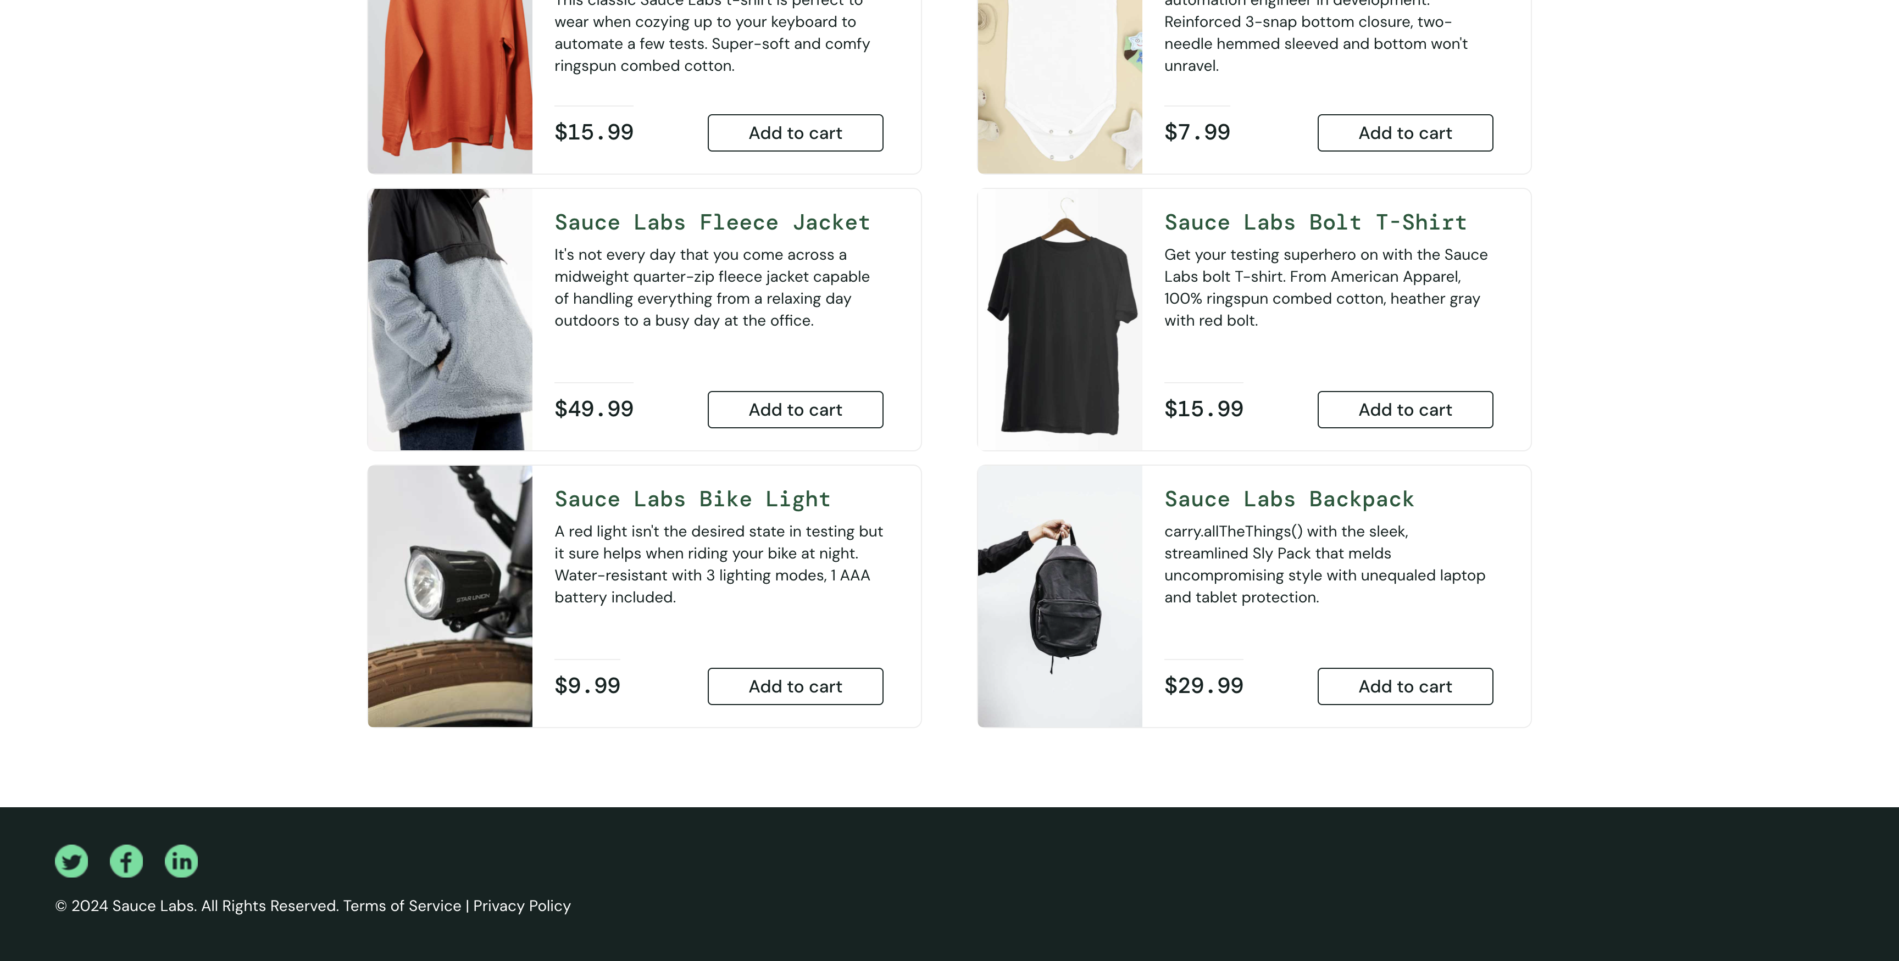

Test name: filterLowToHighTest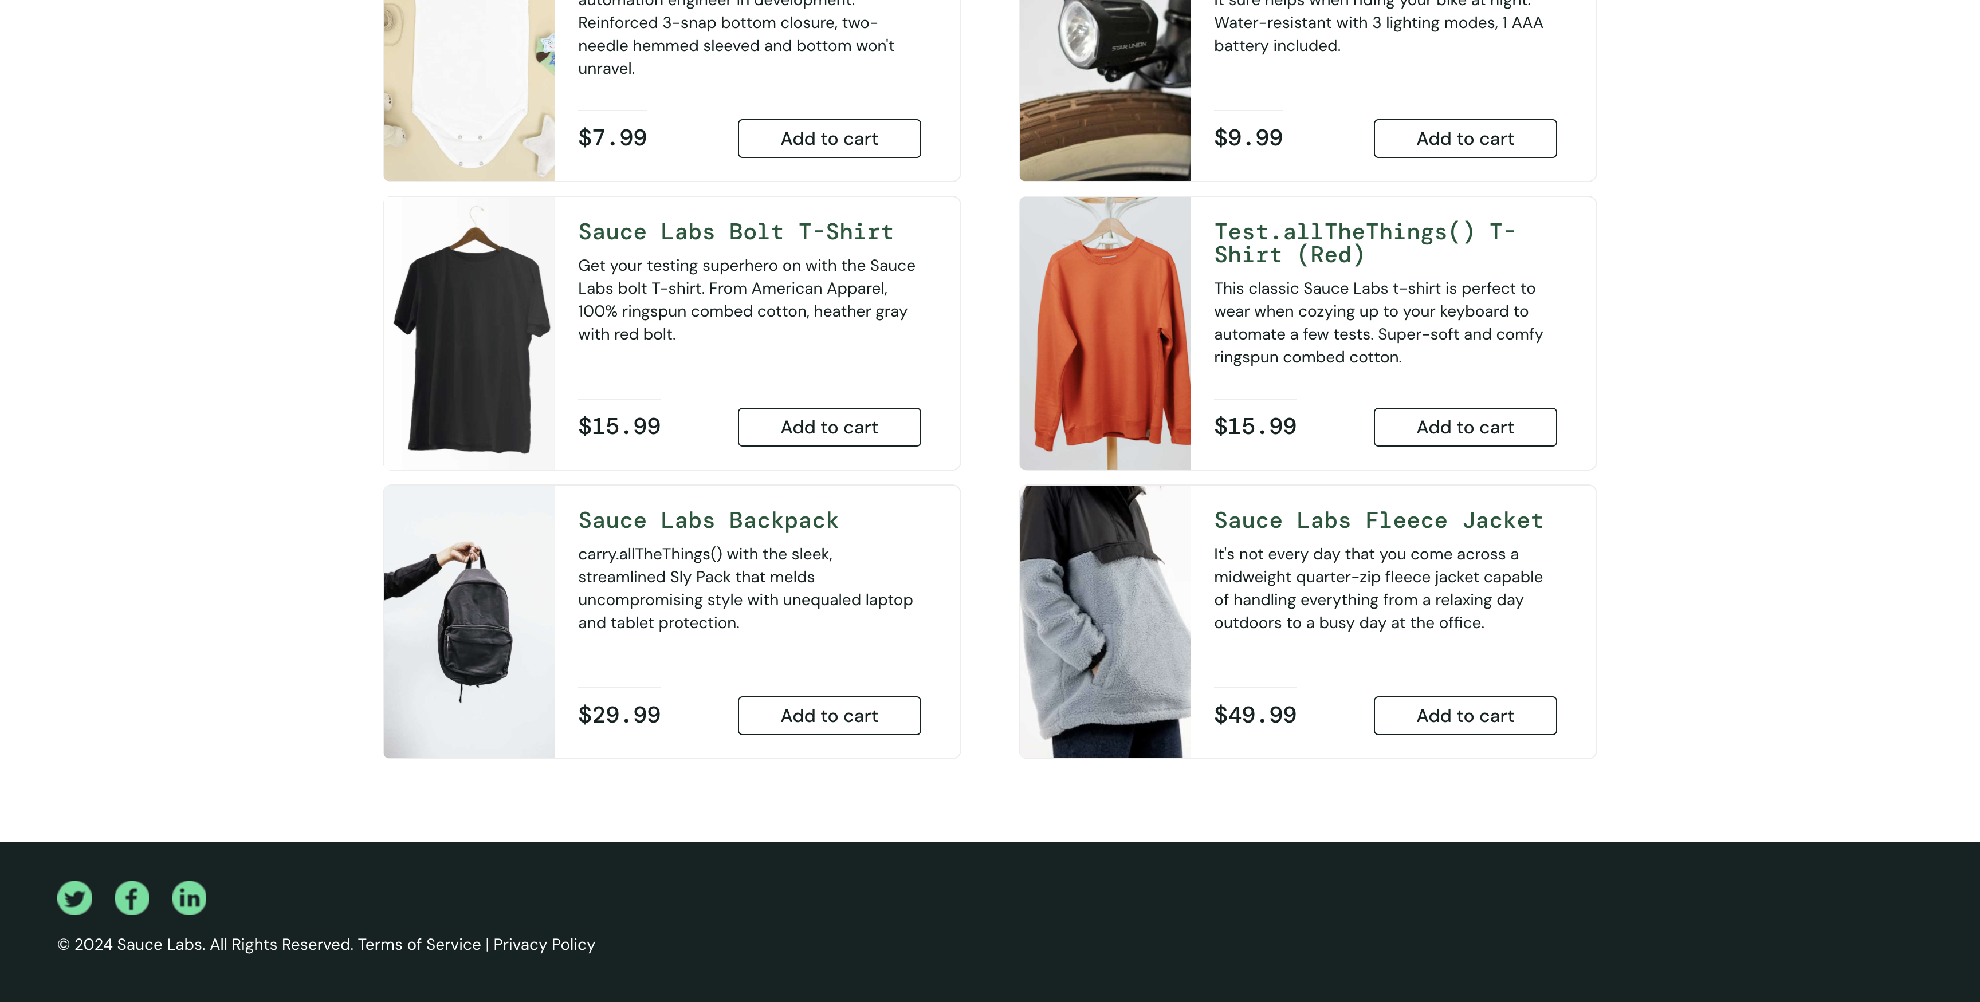

Test name: verifyLoginWithValidUserNameAndPasswordTest

Test name: verifyLoginWithValidUserNameAndPasswordTest

Test name: verifyLockedOutUserTest

Test name: verifyLockedOutUserTest

Test name: verifyProblemUserTest

Test name: verifyProblemUserTest

Test name: verifyPerformanceGlitchUserTest

Test name: verifyPerformanceGlitchUserTest

Test name: verifyErrorUserTest

Test name: verifyErrorUserTest

Test name: verifyVisualUserTest

Test name: verifyVisualUserTest

Test name: verifyLoginWithInvalidUserNameAndPasswordTest

Test name: verifyLoginWithInvalidUserNameAndPasswordTest

Test name: verifyLoginWithInvalidUserNameAndPasswordTest

Test name: verifyLoginWithInvalidUserNameAndPasswordTest

Test name: filterAtoZTest

Test name: filterAtoZTest

Test name: filterZtoATest

Test name: filterZtoATest

Test name: filterLowToHighTest

Test name: filterLowToHighTest

Test name: verifyLoginWithValidUserNameAndPasswordTest

Test name: verifyLoginWithValidUserNameAndPasswordTest

Test name: verifyLockedOutUserTest

Test name: verifyLockedOutUserTest

Test name: verifyProblemUserTest

Test name: verifyProblemUserTest

Test name: verifyPerformanceGlitchUserTest

Test name: verifyPerformanceGlitchUserTest

Test name: verifyErrorUserTest

Test name: verifyErrorUserTest

Test name: verifyVisualUserTest

Test name: verifyVisualUserTest

Test name: verifyLoginWithInvalidUserNameAndPasswordTest

Test name: verifyLoginWithInvalidUserNameAndPasswordTest

Test name: verifyLoginWithInvalidUserNameAndPasswordTest

Test name: verifyLoginWithInvalidUserNameAndPasswordTest

Test name: filterAtoZTest

Test name: filterAtoZTest

Test name: filterZtoATest

Test name: filterZtoATest

Test name: filterLowToHighTest

Test name: filterLowToHighTest

Test name: verifyLoginWithValidUserNameAndPasswordTest

Test name: verifyLoginWithValidUserNameAndPasswordTest

Test name: verifyLockedOutUserTest

Test name: verifyLockedOutUserTest

Test name: verifyProblemUserTest

Test name: verifyProblemUserTest